Online Dealer Sign-Up for ACA
Quick-Start Training Guide
November 2016

Table of Contents

Dealer Setup Overview 1
Before you start 1
Signing in 1
Enter system defaults 3
Set up lender 4
Set up users 4
After signing up 5
Get more information 5

Dealer Setup Overview
This guide provides instructions on these topics:
- Signing up with American Credit Acceptance Corporation (ACA) and AppOne.
- Getting started in the AppOne portal.
On AppOne’s portal, you’ll have access to ACA’s auto collateral program in real time, when you facilitate financing for your customers.

Before you start
You will need to have this information ready before you start:
- Your dealer ID number for ACA.
- Information about your lot, including your Tax ID number and your dealer license number.

Signing in
Navigate to this page:
https://www.appone.net/signup/aca
AppOne recommends you use Internet Explorer, Microsoft Edge, Google Chrome, or Netscape Firefox. Apple computers such as the iMac or MacBook, tablets including the iPad, and smart phones of any kind are not supported by AppOne.
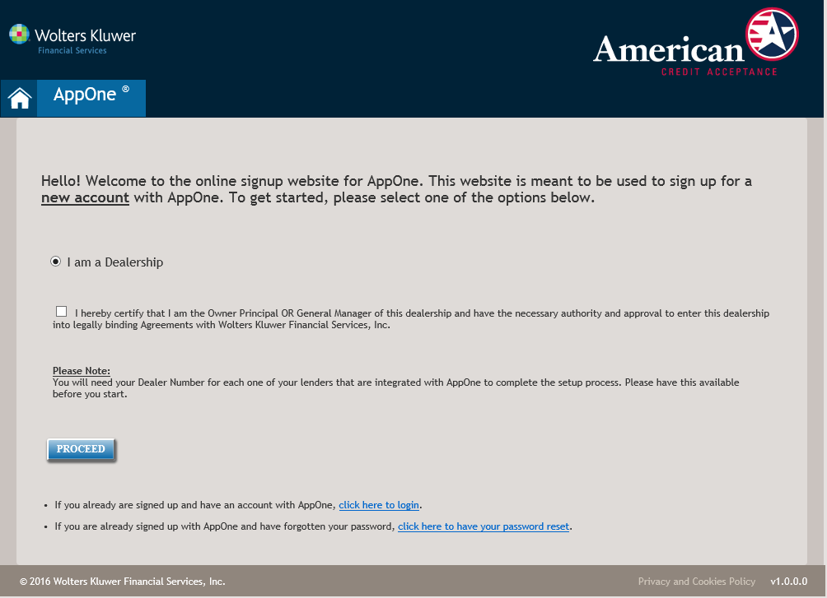

In the Welcome screen:
- Make sure I am a Dealership is selected.
- Check the box to certify that you have the authority and approval to enter the dealership into legally-binding agreements.
- Click Proceed.

In the Information screen
- Fill in the Dealership Information. Fields with a red asterisk (*) are required.
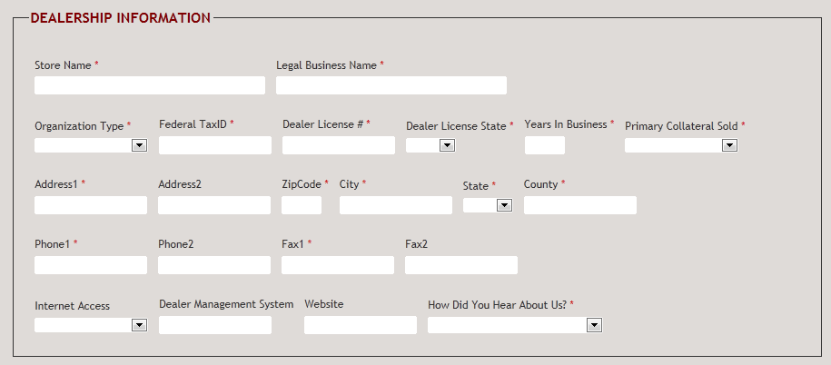E
- Fill in the User Information. Fields with a red asterisk (*) are required.
Note:
AppOne will send you an email confirming your username and password. Make sure you keep track of the username and password, as you will need them to use the portal
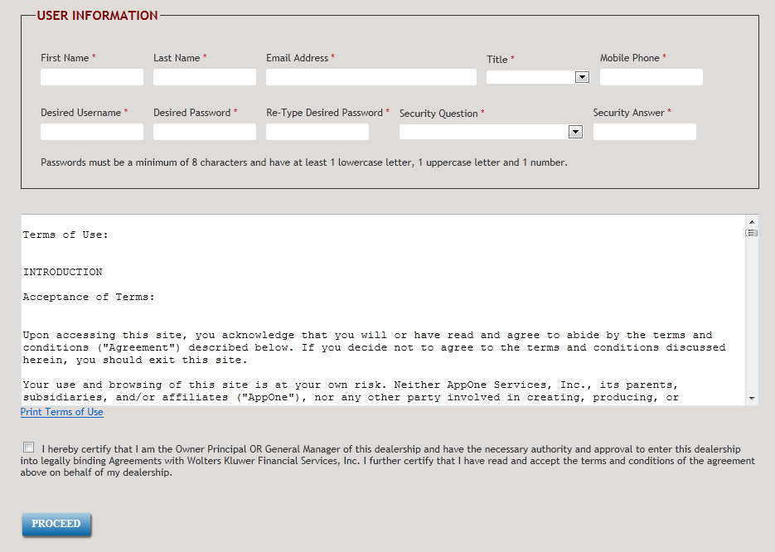
- Check the box to certify you have the authority and approval to enter the dealership into legally binding agreements.
- Click Proceed.

Enter system defaults

On the System Defaults page:
- Set default values for taxes and fees. These will be calculated automatically for your applications.
- Complete back-end product information.
- Click Save.
- When you are done setting up defaults and back-end products, click Proceed to Next Step at the bottom of the page.

Set up lender
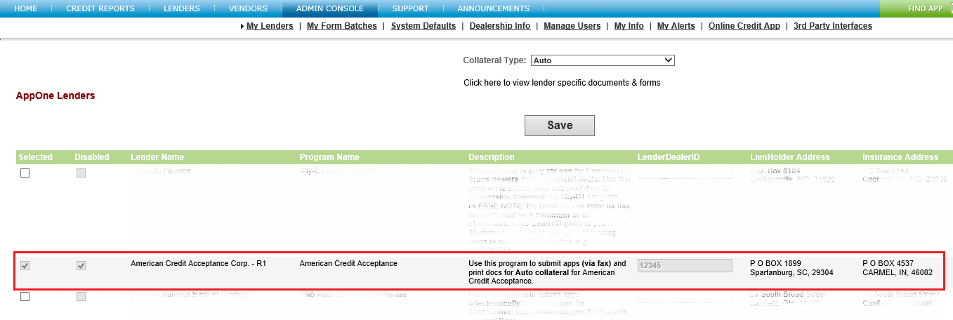

In the AppOne Lenders section:
- Check the box in the Enable column for American Credit Acceptance Corp. A pop-up opens offering three options:
- If you have a dealer ID number for ACA, enter the dealer ID and click Save.
- If you have an agreement with ACA but do not know your dealer ID, click the link for the second option. AppOne gets a dealer ID from the lender, validates it, and sends it to your dealership.
- If you do not have an agreement with the ACA but want more information, click the link for the third option. Enter your contact information in the dialog and click Submit. AppOne sends your contact information to the lender with a request for information.
- Click Save.

When you are done setting up lenders
Click Proceed to Next Step.

Set up users
In the Manage Users page, click Add User to set up a new user. Fill in necessary user information in the Add/Edit User popup, and click Save when you are done.
Note:
A user must have administrative rights to set up a new user or perform other tasks on the Admin Console. To set up a user with administrative rights, select Yes from the Admin list.
When you are done adding users, you are ready to use the AppOne portal. You can also click Proceed to Next Step to set up Alerts. Your ACA form selection rules are setup in the portal for you, so your documents will be selected automatically on the Forms Tab once you enter a deal on the Home Tab.

After signing up
After you have signed up, AppOne will send you a confirmation of your username and password. Make sure you keep a record of these.
After you log out, add the AppOne login page to your Favorites list (Internet Explorer) or Bookmarks list (Firefox and Chrome) so you have it for future reference

Get more information
For more information on AppOne, check the Support tab on the portal.
For support, call 877-277-6631 or email support@appone.net. You can also contact your business development manager (BDM) at 877 -277- 6631, Option 4, or call your BDM directly at the extension listed below.
State | BDM | Email  (firstname_lastname@reyrey.com)
AZ CA CO KS NV TX | Chad Schaefer, Ext. 1207771 | chad_schaefer@reyrey.com
FL IL IN MI MO OH | Nate (Robert) Veldman, Ext. 1207784 | nate_veldman@reyrey.com
AK GA IA ID LA MN MS MT ND NE NM OR SC SD TN UT VA VT WA WI WY | Mike Riley, Ext. 1207931 | michael_riley@reyrey.com
AL AR CT DE KY MA MD ME NC NH NJ NY OK PA RI WV | Kristopher Tovsen, Ext. 1207796 | kristopher_tovsen@reyrey.com

© 2016 AppOne, a Reynolds and Reynolds Business

Publication Information / Version
Full Product Name: AppOne
Document Title: AppOne ACA Dealer Training Guide
Software Version Information: 2016.5.
Document Version Information: 1.0
Release Date: November 2016

AppOne® is a registered trademark of AppOne, a Reynolds and Reynolds Business

