Online Dealer Sign-Up
Quick-Start Training Guide
May 2014

This publication was written for the AppOne .
Publication Information / Version
Full Product Name: AppOne
Document Title: Online Dealer Sign-Up Quick-Start Training Guide
Document Version Information: Version 1.0
Release Date: May 2014
Distributed Subject to Terms of a License or other Agreement
The contents of this publication, including its appendices, exhibits, and other attachments, as updated or revised, are highly confidential and proprietary to Wolters Kluwer Financial Services, Inc. or its subsidiaries or affiliates (“Wolters Kluwer Financial Services”). This publication is distributed pursuant to a Non-Disclosure Agreement, Evaluation Agreement, License Agreement and/or other similar agreement(s) with Wolters Kluwer Financial Services, Inc. or its subsidiary or affiliate. Unless otherwise specifically provided in such agreement(s), the reproduction of this publication is strictly prohibited. Use and distribution of this publication are also subject to the responsibilities and obligations of such agreement(s), which require confidential treatment of this publication and its contents.
Information in this guide is subject to change without notice and does not represent a commitment on the part of Wolters Kluwer Financial Services.
Do Not Reproduce or Transmit
Unless otherwise specifically authorized in the agreement or license under which this publication has been provided, no part of this publication may be posted, played, transmitted, distributed, copied or reproduced in any form or by any means, electronic or mechanical, including photocopying, recording, or retaining on any information storage and retrieval system, without prior written permission from Wolters Kluwer Financial Services.
Requests for permission to reproduce content should be directed to Wolters Kluwer Financial Services, Inc., Corporate Legal Department, by telephone at 1-800-397-2341.
Not a Substitute for Legal Advice
This publication is intended to provide accurate and authoritative information about the subject matter covered based upon information available at the time of publication. Examples given in this publication are for illustrative purposes only.
Development of this publication and the software (including forms, disclosures, reports, and other documents generated by the software) or other products that it describes was based on Wolters Kluwer Financial Services' understanding of various laws, regulations and commentaries. Wolters Kluwer Financial Services cannot and does not guarantee that its understanding is correct.
This publication is not intended, and should not be used, as a substitute for legal, accounting, or other professional advice. Wolters Kluwer Financial Services is not engaged in providing legal, accounting or other professional services. If legal or other professional assistance is required, you should seek the services of a competent professional. We encourage you to seek the advice of your own attorney concerning all legal issues involving the use of this publication and any products described in this publication. If your interpretations or your counsel’s interpretations are contrary to those expressed in this publication, you should of course, follow your/your counsel’s interpretations.
The following notice is required by law:
WOLTERS KLUWER FINANCIAL SERVICES’ PRODUCTS AND SERVICES ARE NOT A SUBSTITUTE FOR THE ADVICE OF AN ATTORNEY.
Warranty Disclaimer
Except only for the warranties (if any) expressly set forth in the agreement(s) under which this publication is provided (i.e., your agreement or license for the described product), this publication is provided “as is”, and Wolters Kluwer Financial Services makes no warranty, express, implied, by description, by sample or otherwise, and in particular and without limitation, makes no implied warranties of merchantability or fitness for purpose. No modifications to this Warranty Disclaimer are authorized unless in writing and signed by the President or a Vice President of the Wolters Kluwer Financial Services entity licensing the product described in this publication.
Attributions and Acknowledgements
ComplianceOne is a trademark of Wolters Kluwer Financial Services, Inc. All other trademarks are the property of their respective owners.
Copyright Information
© 2014 Wolters Kluwer Financial Services, St. Cloud, Minnesota
This publication is the confidential information of Wolters Kluwer Financial Services. Distribution of this publication is subject to restrictions in the license or agreement under which this publication is provided to authorized Wolters Kluwer Financial Institution customers.
All rights reserved.

Table of Contents

Lender Instructions 1
Dealer Instructions 2

Lender Instructions

Modify the dealer instructions:
Fill in the yellow-highlighted fields in the Dealer Instructions section. The following information is required:
- Dealer Name.
- Lender Name.
- Collateral Type.
- Dealer ID Number (the dealer’s ID number for your lender program).
Note
Set up the appropriate program associated with the dealer’s collateral type. Without the right collateral, the dealer will not see the right program and will not get set up correctly.

Send the instructions to the dealer:
Copy contents of the Dealer Instructions section and paste into an email to the dealer, or FAX the instructions to the dealer.

Dealer Instructions
Welcome, I’m from Lender Name. This memo has the instructions you will need to sign up for the Lender Name Collateral Type program and the AppOne portal. On AppOne’s portal, you’ll have access to Lender Name Collateral Type in real time, while you work with your customers.

Before you start
You will need to have this information ready before you start:
- The dealer ID number for Lender Name: Dealer ID Number
- Information about your lot, including your federal tax identifier and your dealer license number.
Before you submit a loan application, watch these training videos to learn more about AppOne:
- Getting Started
- REC Portal Overview
- Submitting an Application
- Printing Documents

Signing in
Navigate to http://www.appone.net/OnlineSignup/Signup. AppOne recommends you use Internet Explorer®. You may use Firefox® or Chrome™ but these browsers are not fully supported by AppOne and you may experience occasional problems.

In the Welcome screen:
- Make sure I am a Dealership is selected.
- Check the box to certify that you have the authority and approval to enter the dealership into legally-binding agreements.
- Click the Proceed button.

In the Information screen
- Fill in the Dealership Information. Fields with a red asterisk (*) are required.
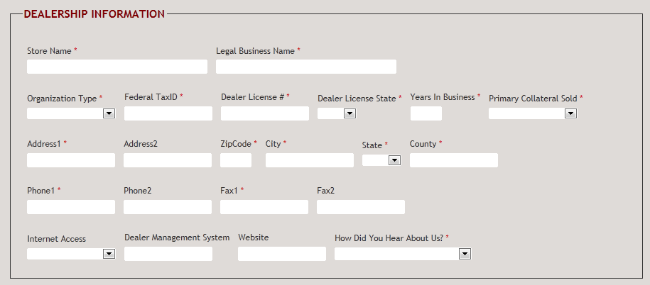E
- Fill in the User Information. Fields with a red asterisk (*) are required.
Note:
AppOne will send you an email confirming your username and password. Make sure you keep track of the username and password, as you will need them to use the portal
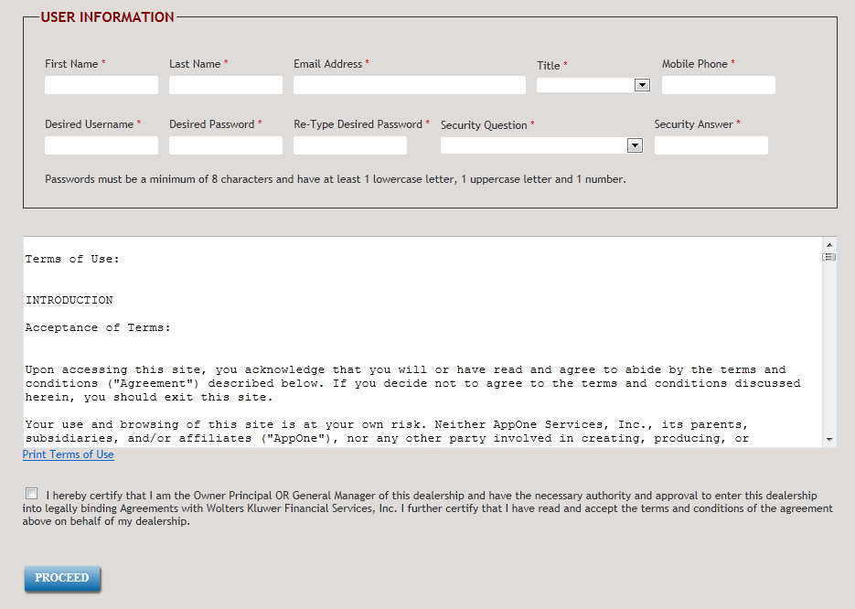
- Check the box to certify you have the authority and approval to enter the dealership into legally binding agreements.
- Click the Proceed button.

Enter system defaults

On the System Defaults page:
- Set default values for taxes and fees. These will be calculated automatically for your applications.
- Complete back-end product information.
- Click Save.
- When you are done setting up defaults and back-end products, click Proceed to Next Step at the bottom of the page.

Set up lenders
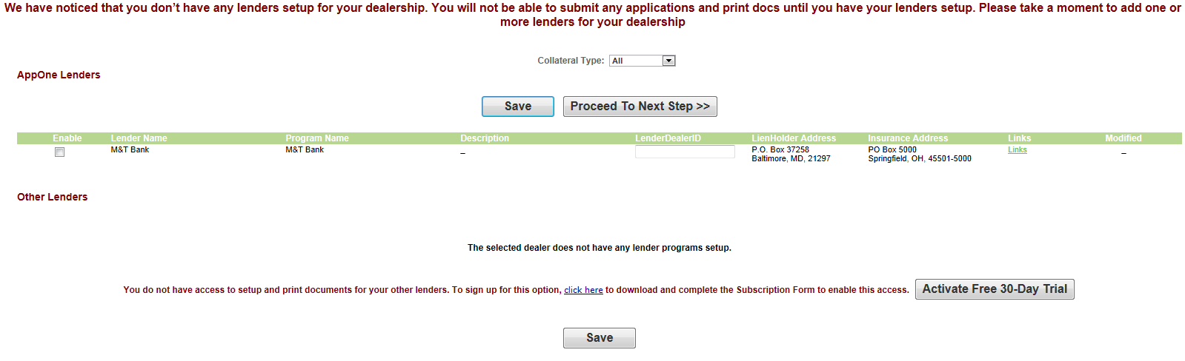

In the AppOne Lenders section:
- Check the box in the Enable column to enable a lender for your dealership.
- Enter Dealer ID Number, the dealer ID for Lender Name, in the LenderDealerID column.
- Click Save.
- If you work with this lender for more than one collateral type, choose the next collateral type from the Collateral Type list and repeat steps 1 through 4 for the new collateral type.


In the Other Lenders section (optional)
To print documents for lenders that are not part of the AppOne platform, enroll in our free 30-day trial.
- Click Activate Free 30-Day Trial.
- To add a lender:
- Click Add Other Lender.
- Fill in the lender, lienholder, and insurance information.
- Click Save in the information popup.
- Click Save in the My Lenders page. Wait a moment for the page to refresh after saving.
- To permanently purchase a subscription, click the click here link.

When you are done setting up lenders
Click Proceed to Next Step.

Set up users
In the Manage Users page, click Add User to set up a new user. Fill in necessary user information in the Add/Edit User popup, and click Save when you are done.
Notes:
Make sure to record the new user’s username and password. The user will need this information to log in.
A user must have administrative rights to set up a new user or perform other tasks on the Admin Console. To set up a user with administrative rights, select Yes from the Admin list.
When you are done adding users, you are ready to use the AppOne portal. You can also click Proceed to Next Step to set up form batches.

After signing up
After you have signed up, AppOne will send you a confirmation of your username and password. Make sure you keep a record of these.
After you log out, add the AppOne login page to your Favorites list (Internet Explorer) or Bookmarks list (Firefox) so you have it for future reference

Get more information
If you have questions about getting set up call 877-404-6788 (Specialty Dealer Portal SupportLine).
If you have questions about setting up subscription, call 1-877 -277- 6631, Option 4.
For more information on AppOne, see the AppOne REC Quick-Start Training Guide or check the Support tab on the portal.
You can also learn more about AppOne from our training videos:
- Getting Started
- REC Portal Overview
- Submitting an Application
- Printing Documents


About Wolters Kluwer Financial Services - Whether complying with regulatory requirements or managing financial transactions, addressing a single key risk, or working toward a holistic enterprise risk management strategy, Wolters Kluwer Financial Services works with more than 15,000 customers worldwide to help them successfully navigate regulatory complexity, optimize risk and financial performance, and manage data to support critical decisions. Wolters Kluwer Financial Services provides risk management, compliance, finance and audit solutions that help financial organizations improve efficiency and effectiveness across their enterprise. With more than 30 offices in 20 countries, the company’s prominent brands include: AppOne®, ARC Logics®, AuthenticWeb™, Bankers Systems, Capital Changes, CASH Suite™, FRSGlobal, FinArch, GainsKeeper®, NILS®, TeamMate®, Uniform Forms™, VMP® Mortgage Solutions and Wiz®. Wolters Kluwer Financial Services is part of Wolters Kluwer, a leading global information services and solutions provider with annual revenues of (2013) €3.6 billion ($4.7 billion) and approximately 19,000 employees worldwide. Please visit our website for more information.

Wolters Kluwer Financial Services
6815 Saukview Drive
St. Cloud, MN 56303
Toll-free: 800.274.2711
To learn more visit WoltersKluwerFS.com.
© 2014 Wolters Kluwer Financial Services, Inc. All Rights Reserved.

