Setup and Implementation
  - Fannie Mae Desktop Underwriter

Date December 2020
File Fannie Mae Desktop Underwriter Setup and Implementation
Disclaimer
The contents of this publication, including its appendices, exhibits, and other attachments, as updated or revised, are highly confidential and proprietary to Wolters Kluwer Financial Services, Inc. or its subsidiaries or affiliates (“Wolters Kluwer Financial Services”). This publication is distributed pursuant to a Non-Disclosure Agreement, Evaluation Agreement, License Agreement and/or other similar agreement(s) with Wolters Kluwer Financial Services, Inc. or its subsidiary or affiliate. Unless otherwise specifically provided in such agreement(s), the reproduction of this publication is strictly prohibited. Use and distribution of this publication are also subject to the responsibilities and obligations of such agreement(s), which require confidential treatment of this publication and its contents.
Except only for the warranties (if any) expressly set forth in the agreement(s) under which this publication is provided (i.e., your agreement or license for the described product), this publication is provided “as is”, and Wolters Kluwer Financial Services makes no warranty, express, implied, by description, by sample or otherwise, and in particular and without limitation, makes no implied warranties of merchantability or fitness for purpose. No modifications to this Warranty Disclaimer are authorized unless in writing and signed by the President or a Vice President of the Wolters Kluwer Financial Services entity licensing the product described in this publication.
This publication is intended to provide accurate and authoritative information about the subject matter covered based upon information available at the time of publication. Examples given in this publication are for illustrative purposes only.
Development of this publication and the software (including forms, disclosures, reports, and other documents generated by the software) or other products that it describes was based on Wolters Kluwer Financial Services’ understanding of various laws, regulations and commentaries. Wolters Kluwer Financial Services cannot and does not guarantee that its understanding is correct.
This publication is not intended, and should not be used, as a substitute for legal, accounting, or other professional advice. Wolters Kluwer Financial Services is not engaged in providing legal, accounting or other professional services. If legal or other professional assistance is required, you should seek the services of a competent professional. We encourage you to seek the advice of your own attorney concerning all legal issues involving the use of this publication and any products described in this publication. If your interpretations or your counsel’s interpretations are contrary to those expressed in this publication, you should of course, follow your/your counsel’s interpretations.
The following notice is required by law:
WOLTERS KLUWER FINANCIAL SERVICES’S PRODUCTS AND SERVICES ARE NOT A SUBSTITUTE FOR THE ADVICE OF AN ATTORNEY.
Copyright
Unless otherwise specifically authorized in the agreement or license under which this publication has been provided, no part of this publication may be posted, played, transmitted, distributed, copied or reproduced in any form or by any means, electronic or mechanical, including photocopying, recording, or retaining on any information storage and retrieval system, without prior written permission from Wolters Kluwer Financial Services.
Requests for permission to reproduce content should be directed to Wolters Kluwer Financial Services Corporate Legal Department, by telephone at 1.800.397.2341.
Trademark Rights
All trademarks are the property of their respective owners.
6815 Saukview Drive
St. Cloud, MN 56303
© 2020 Wolters Kluwer Financial Services, Inc.

Content
Fannie Mae Desktop Underwriter 4
Setup and Implementation 4
Before You Begin 4
Tasks to Complete 4

Fannie Mae Desktop Underwriter

Setup and Implementation
Wolters Kluwer has partnered with Fannie Mae to offer mutual customer access to Fannie Mae’s Desktop Underwriter system via an integration with ComplianceOne mortgage and ComplianceOne assumptions. After configuration, the Desktop Underwriter Interface enables fulfilment of automated underwriting services between ComplianceOne and Desktop Underwriter so that a lender can originate mortgage loans through ComplianceOne with terms and conditions that adhere to Fannie Mae’s conditions to purchase the loans upon consummation. Within the Desktop Underwriter Interface, users can send required mortgage loan information from ComplianceOne to Desktop Underwriter, initiate automated underwriting services, receive results and view purchase eligibility results from Desktop Underwriter within the ComplianceOne system in the form of one-to-many HTML reports. The ComplianceOne Interface manages sending the AUS request with the correct data to the Desktop Underwriter system during the interim period-of-time when both versions of the Universal Residential Loan Application (URLA) can be used.

Before You Begin
The following are required from Fannie Mae before you set up and implement Desktop Underwriter with ComplianceOne.
- A valid Fannie Mae Institution ID – generally represents the Institution who has contracted to sell loans to Fannie Mae.
- An existing Fannie Mae Desktop Underwriter User Name and Password.
- An agreement with one or more credit reporting companies (CRCs) or their affiliated companies to use merged credit report options within Desktop Underwriter.
- If you intend to pull credit via ComplianceOne SaaS prior to requesting Desktop Underwriter services, you must be set up and successfully using a ComplianceOne SaaS supported Credit Service Provider – Factual Data, CBCInnovis, or SettlementOne.
- If you intend to underwrite FHA loans via DU for Government Loans, you must be an approved FHA loan Originator and have a FHA Lender ID and/or FHA Sponsor ID as applicable. Note: Underwriting FHA loans from ComplianceOne to DU for Government Loans is not currently supported.

Tasks to Complete
Achieving a successful implementation of the Fannie Mae Desktop Underwriter system with ComplianceOne requires completion of the following tasks:
- Obtain a license for use of the Desktop Underwriter Interface for ComplianceOne SaaS with Wolters Kluwer. This is a contract event between your Financial Institution and Wolters Kluwer.
Note
After completion of this contract event, your designated ComplianceOne System Administrator will receive an email confirming entitlement to the Wolters Kluwer Desktop Underwriter Interface for your designated ComplianceOne Account in both the ComplianceOne Customer Test and ComplianceOne Production SaaS environments.

- The ComplianceOne System Administrator configures Interface Manager in the ComplianceOne Customer Test SaaS environment with the information noted in the above “Before you Begin” section by completing the following steps:
  - Log into Interface Manager in the Customer Test environment using the following URL: https://interfacemanagertest.wolterskluwerfs.com/InterfaceManager/
Note
You will see the Available Interfaces page with a list of all Interfaces that are available to be configured for an Account. You can switch to different Accounts by using the Account drop-down list available in the upper right corner of the screen.
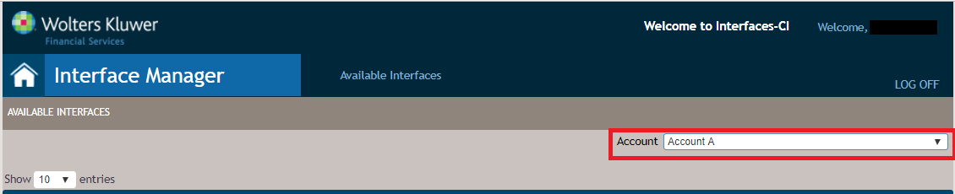

  - Select your licensed account from the Account drop-down list.
  - Locate and select Desktop Underwriter from the list of available interfaces.
Note
- Available licensed interfaces are listed in alphabetical order.
- Selection of this available interface will take you to the Settings page for the Fannie Mae Desktop Underwriter Interface. You will not make any changes or additions to the Settings page.

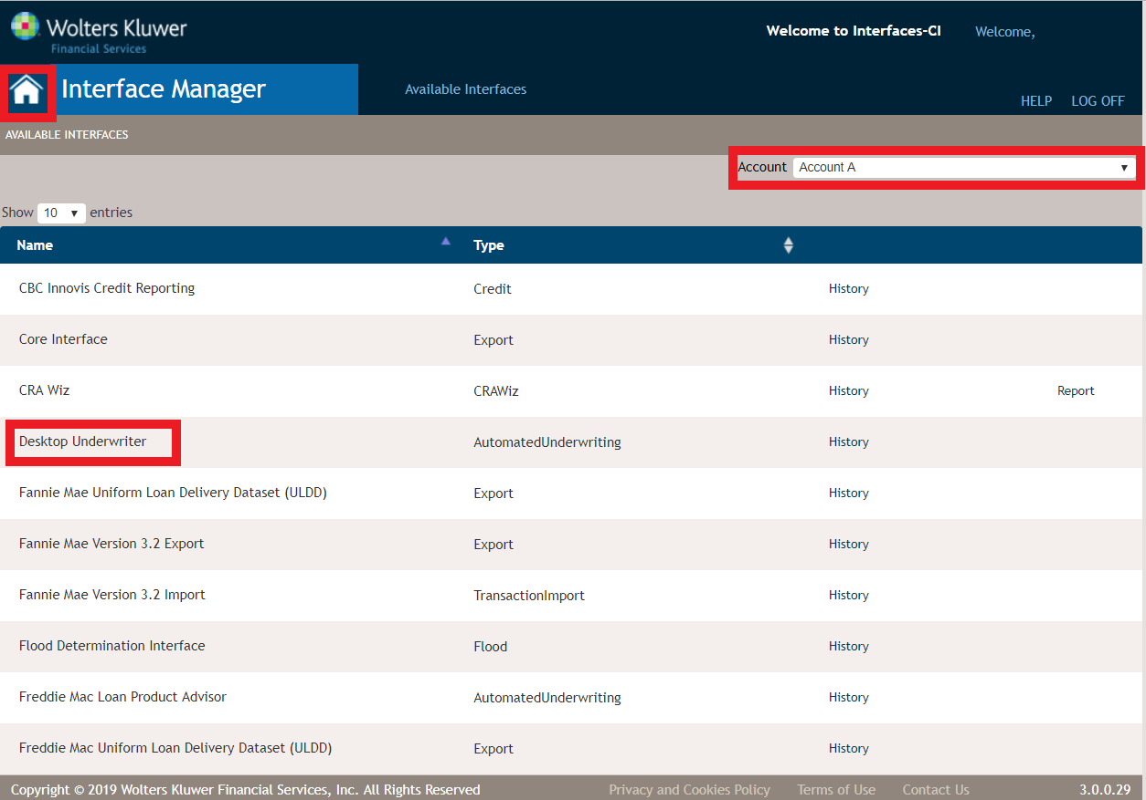
  - On the Setttings page for the Desktop Underwriter Interface, select Parameters and Resources.
- The Parameters and Resources page displays resources and parameters that apply to an interface.
- The name of the parameter is always defined by the interface; the value is set by the user.
- Resources are configuration files that are used by the interface. The files are either XSL (stylesheets) or XML.
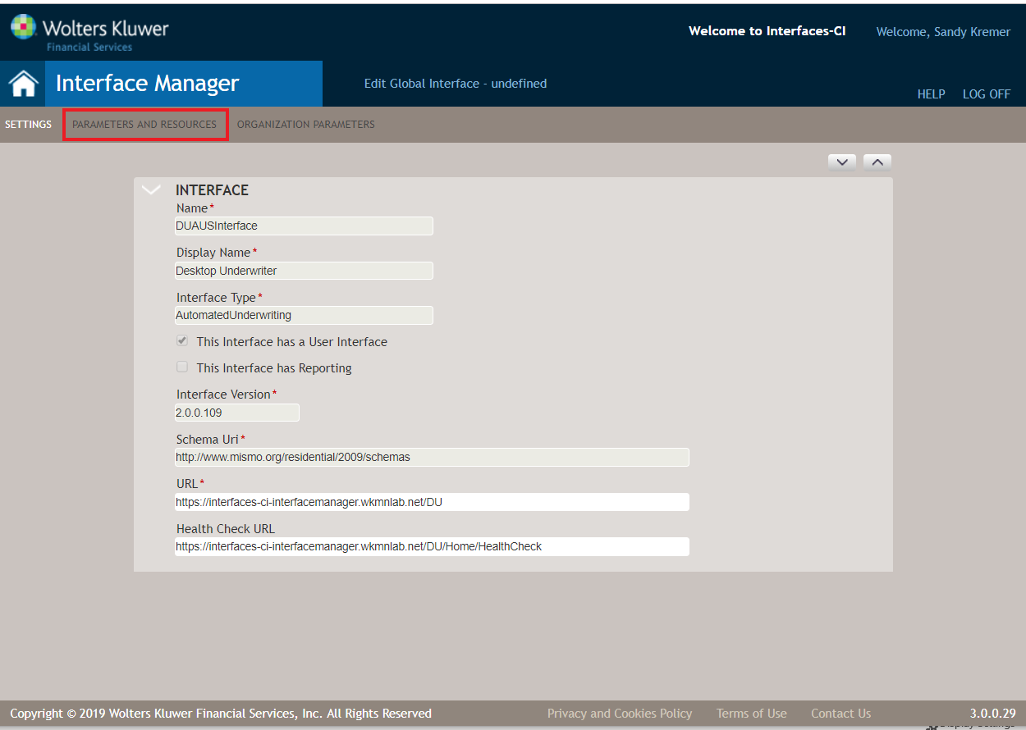

Note
The Desktop Underwriter Interface does not use the Global Parameters or Account Resources functionality. It does use Global Resources to house the HTML Report stylesheets used for presenting the service feedback results to the user within the interface.

  - On the Accounts and Parameters page, expand Account Parameters. Configure the values for the named items on the Account Parameters page as noted in the table below. Account Parameters are values that are applied to an interface across the entire account.
Name | Value
UserName | Enter the Financial Institution User Name provided by Fannie Mae.
Password | Enter the Password for the above User Name initially provided by Fannie Mae.
InstitutionID | Enter the Institution ID provided by Fannie Mae.
ServiceProviderCode | Enter the Credit Service Provider ID code contracted with for Credit Services external to ComplianceOne use.
ServiceProviderAccountNumber | Enter the Account Number associated with your contract with the Credit Service Provider.
ServiceProviderPassword | Enter the Password associated the Credit Service Account Number for DU to access credit services form the serivce provider’s system during the AUS request.
FHALenderID | Not Currently Supported
FHASponsorID | Not Currently Supported
DesktopUndewriterURL | Enter the URL to the Fannie Mae Desktop Underwriter service endpoint for the Integration (Test) environment: https://direct.intgfanniemae.com/servicerequest2
  - Select the Home button in the header of Interface Manager to save and exit configuration of the Desktop Underwriter Interface in Interface Manager.
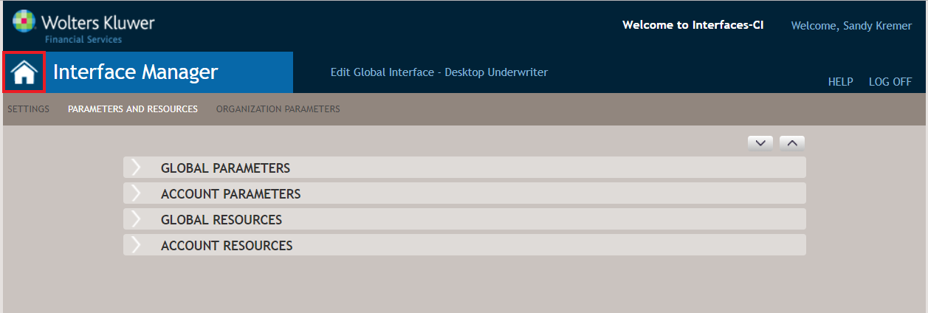
  - Repeat steps a-f for all applicable licensed Accounts in the Customer Test environment.
- The ComplianceOne System Administrator repeats task #2 (steps a-g) to configure Interface Manager in the ComplianceOne Production SaaS environment with information with the following variation:
  - Log into Interface Manager in the Production environment using the following URL: https://interfacemanager.wolterskluwerfs.com/InterfaceManager/
  - All values for the parameters will be the same as those entered within the Customer Test environment except for the DesktopUnderwriterURL:
https://direct.efanniemae.com/servicerequest2 [Production Environment]
  - Repeat steps a-b for all applicable licensed Accounts in the Production environment.
- Validate successful setup and implementation of Desktop Underwriter with ComplianceOne by performing a Desktop Underwriter request from within ComplianceOne with a test transaction in the Customer Test environment by a permissioned User.

Your ComplianceOne solution is now configured for use of Fannie Mae Desktop Underwriter in the Customer Test and Production environments.
Note
ComplianceOne users must have permissions to use Interface Manager before they can select “Automated Underwriting” from the the available interfaces menu in ComplianceOne. For more information, refer to Roles section of Help in Security Administration.

For additional Resources on using the Fannie Mae Desktop Underwriter solution, select or go to : https://www.fanniemae.com/singlefamily/desktop-underwriter

