Oracle 11g Client Installation

- Browse to \\nastnmn0201\xfer\CMS-Installers and copy win32_11gR2_client.zip to your local machine:
- Unzip the downloaded file
- Run \client\setup.exe

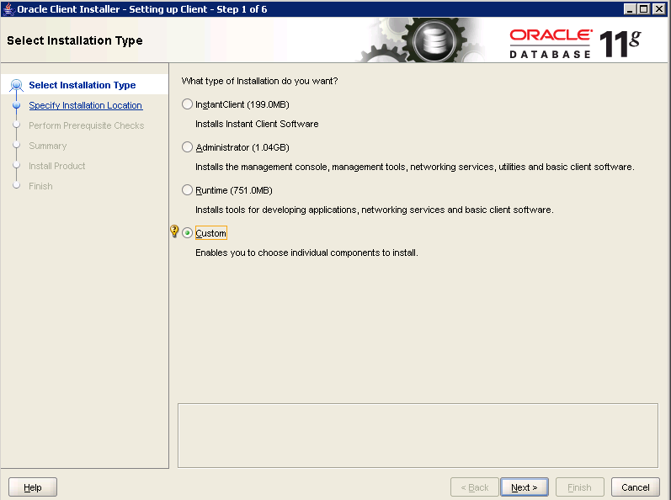
Select Custom
Click on Next

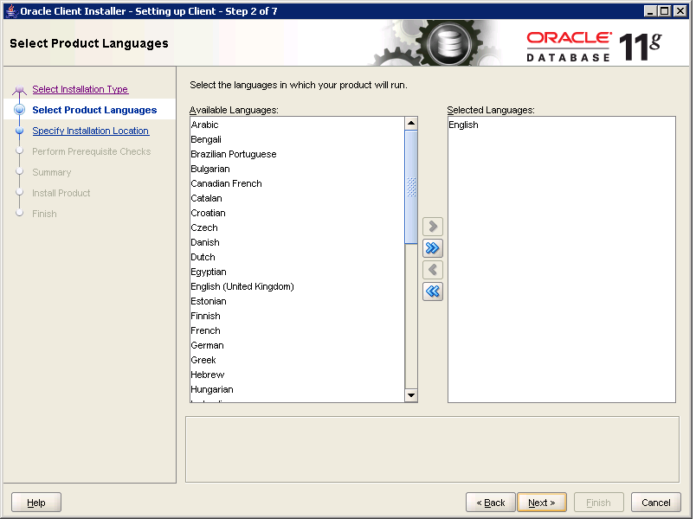
English should appear as the Selected Language. Click on Next.
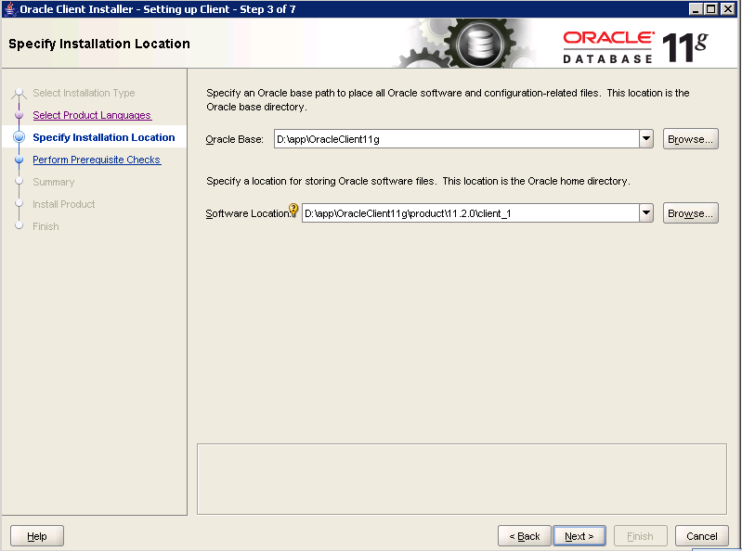
Oracle Base: C:\app\OracleClient11g
Software Location: C:\app\OracleClient11g\product\11.2.0\Client_1
Click on Next

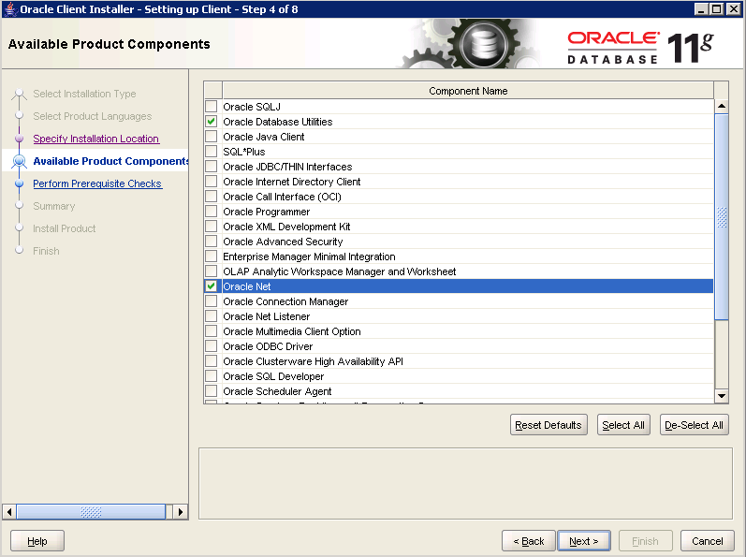
Select:
Oracle Database Utilities and
Oracle Net
Click on Next
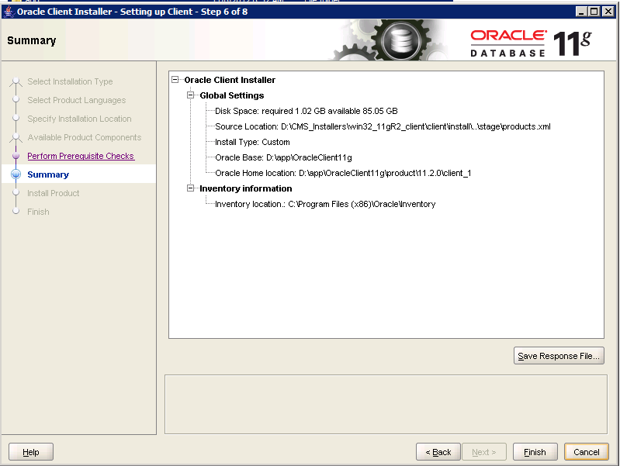
Click the Finish button
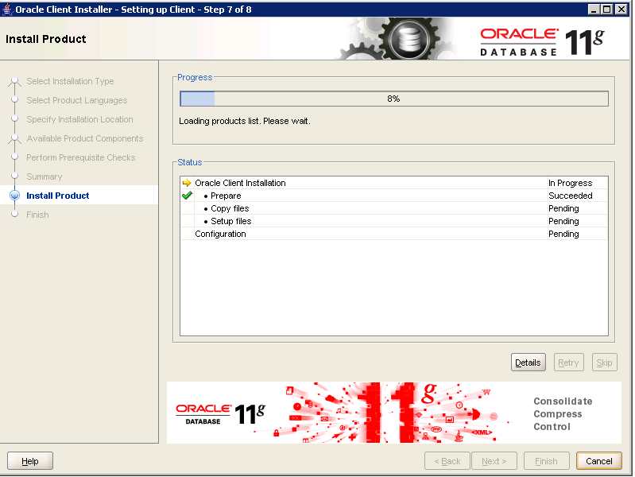
The selected components will be installed.
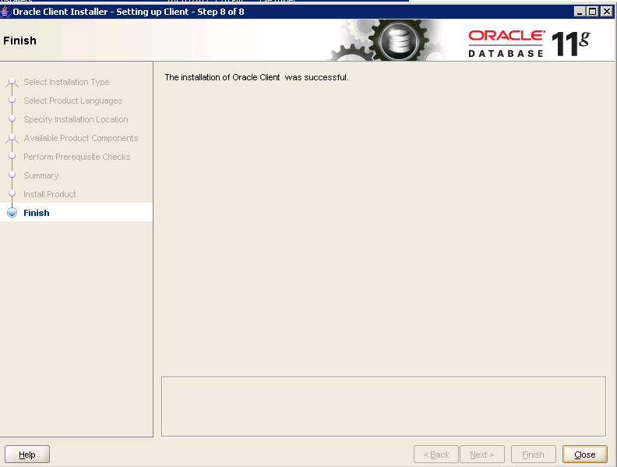
Select Close
Copy the \xfer\CMS-Installers\tnsnames.ora to C:\app\OracleClient11g\product\11.2.0\client_1\network\admin

